TECHNICAL PROPOSAL

For preparation of Internet service by developing an intranet system, In Kamalamai Municipality Office and ward 1 to 14: 2076/077

Contract Package No.:

SUBMITTED TO

Government of Nepal

Kamalamai Municipality

Sindhuli, Nepal

Submitted By:

Acosaf Technology Pvt. Ltd

Itahari-6

(Reg.No.192222/74/075)

Itahari, Sunsari

Table of Contents

Contents

1. Introduction 1

1.1. Backgrounds 1

1.2. Objectives 2

1.3. Working area description 2

1.4. Silent Features of the Project 3

2. The Consultant 5

2.1. The Firm:Acosaf Technology Pvt. Ltd. 5

3. APPROACH AND METHODOLOGY 6

3.1. Approach 6

3.2. Methodology 6

3.2.1. Formation of Expert Team 6

4. Expected Output 7

5. Duration and Time Frame 8

6. Consultant 8

7. Annexes 9

# Introduction

## Backgrounds

With regard to Nepal's federal democratic system, the concept of decentralization has been made the basic medium. In order to provide equitable access, service and facilities to all the class through the information technology in the services of the flow of the state, the state has made special arrangements for the local bodies or the local level. The government has set up the revenue counter office to make the local government the power of the government, to make the customs line profitable, to make the tax scandalistic, tax technologies, and to make taxes to the people, by establishing a revenue counter at local ward level office, integrating the local level as a developed nation, by implementing the networking system, safely administering data on the data server and cloud Whether it is necessary to see immediately required data or not; this is why it is required to build the centralized networking system.

**An Intranet**

An intranet is an exclusive network that can be accessed only by a specific group of people and no one else. Many corporations, government agencies and universities have their own intranet.

Intranets can act as communication hubs for staff. You can store corporate information such as memos, staff news and announcements centrally and access at any time.

Typically, the IT department of an organization runs an intranet. They control the access, networking and security, and they rely on other departments—training, marketing, human resources, public relations, etc.—to provide and update the content.

To implement this type of server based technology there should be latest networking equipments like servers, CISCO router, Optical fiber, media converter, Microtek routers, Wireless networking devices and so on.

By implementing this technology, Kamalamai Municipality will move to the modern technological era like other developed cities.

## Objectives

The overall objective of this project is to establish an interconnected networking system to all of the municipal offices like office of executive, ward offices and other quarters of the respective officers in Kamalamai Municipality.

* To construct an Internet and Intranet system with data server technology.
* To create an IP telephony system which will provide telephone line at ward offices; the place which is geographically inaccessible from technology right now.
* To develop an integrated tax system with every ward office of municipality.
* To provide the internet services through the own tower having height of 70 ft tall from the ground.
* To make technology and digital world friendly municipality.

## Working area description

Kamalamai Municipality is located in Southern part of Sindhuli district, Province No.3 of Central Nepal. While there is a problem in building the information and technology system, due to a geographical view of the municipalities in the hilly area to build the own data server by expanding the Internet and internet in the office of Kamalamai Municipality and all 14 ward offices of the municipal council.

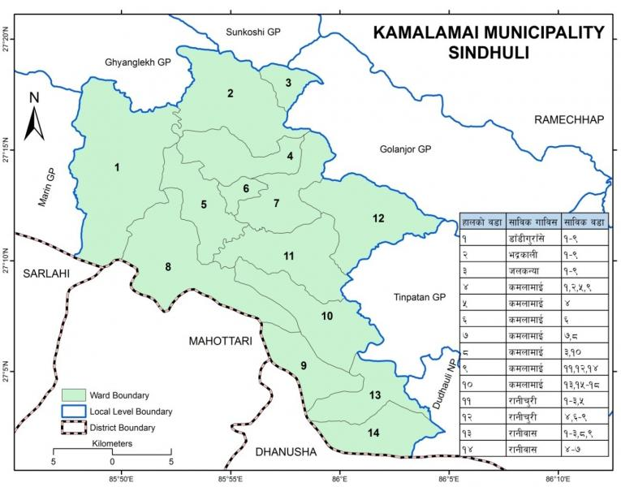

Figure 1: Map of Kamalamai Municipality

## Silent Features of the Project

Name of the Project : For preparation of Internet service by developing an Intranet system, in Office of Municipal Executive and ward 1 to 14: 2076/077

**Project Classification**: New, Extension

**Location**

Municipality : Kamalamai Municipality Office

Wards : 1 to 14

Latitude: 27.210088 N

Longitude: 85.912285 E

District: Sindhuli

Development Region: Central

Province No. : 3

**Client** : Kamalamai Municipality

For preparation of Internet service by developing an Intranet system, in Kamalamai Municipality Office and ward 1 to 14: 2076/077

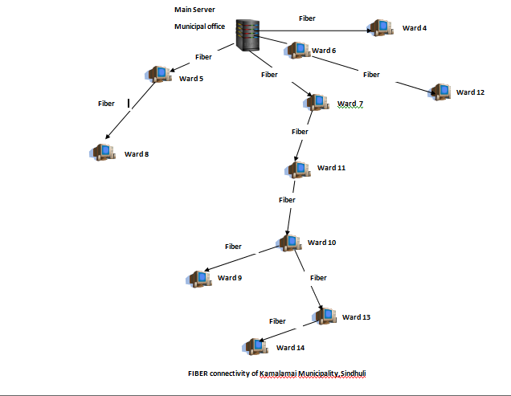

# The Consultant

## The Firm:Acosaf Technology Pvt. Ltd.

**Introduction**

Acosaf Technology Pvt. Ltd was established on **22th June,2018** and is Itahari based company managed by highly experienced information technology professionals and offers consulting services in the areas of Software Development, IT Infrastructure Management, Security Infrastructure design, Quality Assurance and implementation. Acosaf Technology has considerable experience delivering solutions in single and multi operating system environments.

Acosaf Technology through its alliances is able to attain goals and objectives which one company cannot achieve alone. These are based on a win-win mindset, mutual trust, commitment and the sharing of risks and rewards to benefit customers directly. Our professionals have several hundred person-years of experience consulting with organizations and implementing our proposed and customer desired solutions.

# APPROACH AND METHODOLOGY

## Approach

The consultant has formulated the approach to meet the installation of Intranet requirements outlined in the ToR. The following are the general approaches to be adopted in the installation of intranet.

* Survey for the installation of network at ward's office and location of tower
* Installation of network Fiber cable
* Server installation and configuration
* Testing and troubleshooting of network

## Methodology

The following major activities shall be carried out to fulfill the installation of intranet according to ToR.

Acosaf Technology follows standard industry process models such as Spiral (incremental), Waterfall and Rapid Prototyping. Our methodology is determined based on the client's requirement and our vision is to always be a part of the client's success. Based on our vast experience in implementation of quality solutions for various clients, we recommend the spiral model for most projects as it helps reduce risk and time to market.

We have plan documentation templates ready for managing teams and various aspects of software development. Our development process involves planning and documenting specifically for each project aspect such as: Development Infrastructure & environment setup; Development methodologies; Project team set-up and resource ramp up; Resource management and attrition planning; Delivery management; Software configuration management; Quality management; Performance management; Metrics collection, Analysis & reporting.

### Formation of Expert Team

Firstly, Expert team will be formed. This team member constitutes a team of IT expert, CCNA, Hardware & Networking, ISP expert, DIT expert and expert technician in network installation. A fulltime workplace will setup to ensure full time work environment.

# Expected Output

* After completion of this project a fully functional Intranet network system will be established with internet facility in Kamalamai Municipality.
* Kamalamai Municipality can use and control internet bandwidth from office of municipal executive through dedicated server.
* This system helps to share and collect information from Kamalamai Municipality Wards.
* This system can help to establish the revenue tax counter at every ward level.

# Duration and Time Frame

This consultancy will cover a period of 25 working days starting from the date of signing the contract.

# Consultant

Short information about the service provider is given below and detail in Annex.

Acosaf Technology Pvt.Ltd.

Itahari Sub-metropolitan City, Sunsari, Nepal

Contact Person: Diwakar Poudel

Email: [acosafinfo@gmail.com](mailto:acosafinfo@gmail.com)

Contact No.: 977-9852048740

# Annexes

**Technical and geographical estimations:**

Latitude and Longitude of Municipality Office: 27.210088,85.912285

|  |  |  |  |  |
| --- | --- | --- | --- | --- |
| From(Ward-Ward) | Latitude & Longitude | Air distance* | Road distance* | Wire Length Consideration (Round off figure) |
| 1 | 27.250918,85.831633 | 7 km | 14.84 km | 16 km |
| 2 | 27.281233,85.916532 | 8 km | 15.16 km | 17 km |
| 3 | 27.303482,85.945517 | 10.9 km | 11 km | 12 km |
| Mun-4 | 27.228368,85.914718 | 2 km | 2.5 km | 2.6 km |
| Mun-5 | 27.208425,85.910453 | 260 m | 400 m | 420 m |
| Mun-6 | 27.211230,85.912815 | 140 m | 140 m | 145 m |
| Mun-7 | 27.203634,85.919769 | 1 km | 1.6 km | 2 km |
| 8 | 27.157841,85.906371 | 4 km | 10.2 km | 10.6 km |
| 9 | 27.104308,85.964798 | 1 km | 6.20 km | 6.5 km |
| 11-10 | 27.102453,85.979945 | 5 km | 27.6 km | 28.5 km |
| 7-11 | 27.174374,85.983109 | 6.9 km | 10.5 km | 11 km |
| 6-12 | 27.088989,85.965980 | 10 km | 20 km | 20.6 km |
| 10-13 | 27.05332,85.03256 | 21.11 km | 23 km | 25 km |
| 13-14 | 27.07598,85.01979 | 18.32 km | 20 km | 22 km |

*Distance is calculated considering Municipality Office as source geographical point.

Note: Length of wire is calculated by adding 3% to the total road distance and considering technical requirements and geographical condition between source and destination.

**Analyzer:**

Santu Deola

(MSCIT,MSCA)